CPE301 – SPRING 2019

Design Assignment 2C

Student Name: John Patrick Buen

Student #: 2000900752

Student Email: buenj1@unlv.nevada.edu

Primary Github address: https://github.com/buenj1/submission_da.git

Directory:

Submit the following for all Labs:

1. In the document, for each task submit the modified or included code (only) with highlights and justifications of the modifications. Also, include the comments.
2. Use the previously create a Github repository with a random name (no CPE/301, Lastname, Firstname). Place all labs under the root folder ESD301/DA, sub-folder named LABXX, with one document and one video link file for each lab, place modified asm/c files named as LabXX-TYY.asm/c.
3. If multiple asm/c files or other libraries are used, create a folder LabXX-TYY and place these files inside the folder.
4. The folder should have a) Word document (see template), b) source code file(s) and other include files, c) text file with youtube video links (see template).

1. **COMPONENTS LIST AND CONNECTION BLOCK DIAGRAM w/ PINS**

Components: atmega328p Xplained Mini board, Multi-function Shield board, micro USB

Block Diagram:

ATMEGA328P block diagram:

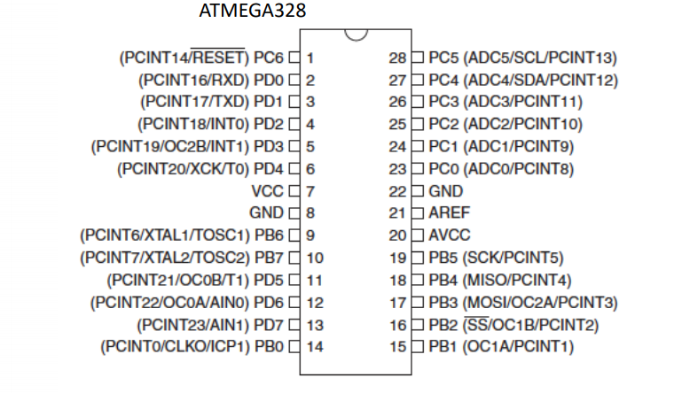

1. **INITIAL/MODIFIED/DEVELOPED CODE OF TASK 1**

Using timer0 in Normal mode, with 1024 prescaler

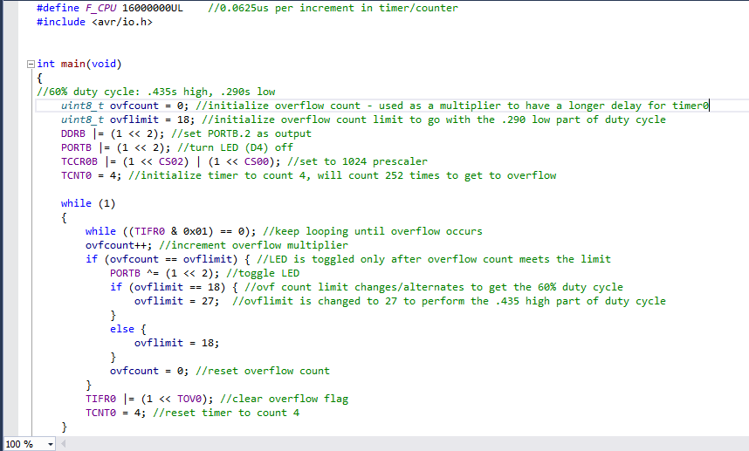

Using switch (PORTC.2) to light up LED for 1.25s delay (**PART II**)

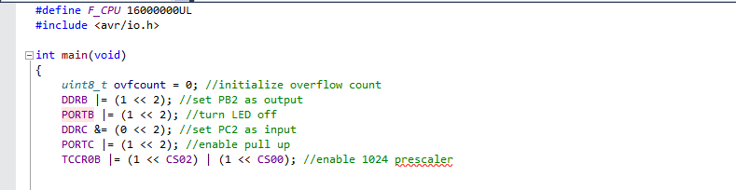

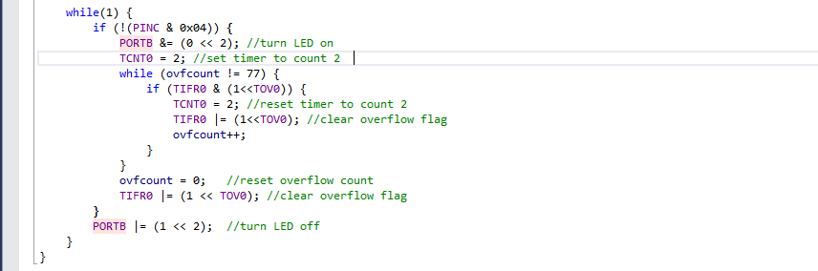

1. **DEVELOPED MODIFIED CODE OF TASK 2**

Using timer0 in Normal mode with the 1024 prescaler, using timer overflow interrupt

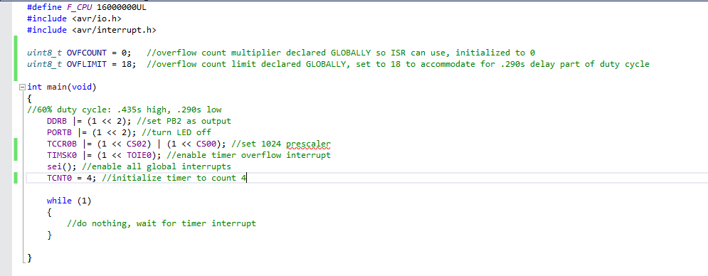

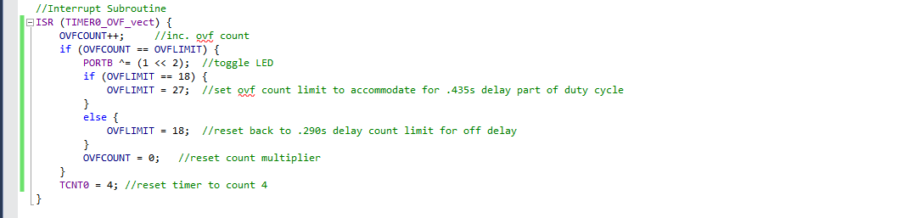

1. **DEVELOPED MODIFIED CODE OF TASK 3**

Using timer0 with 1024 prescaler in CTC mode, using output compare timer interrupt

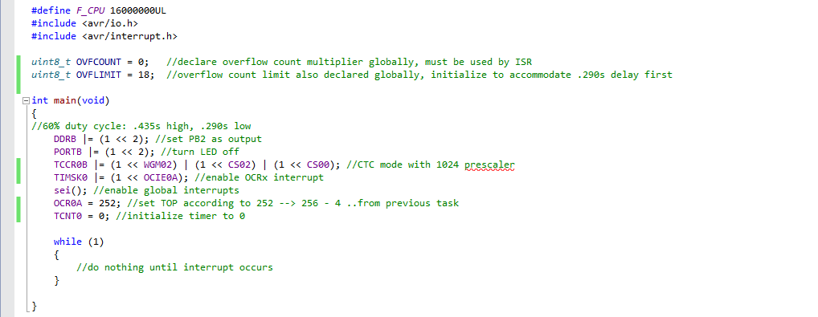

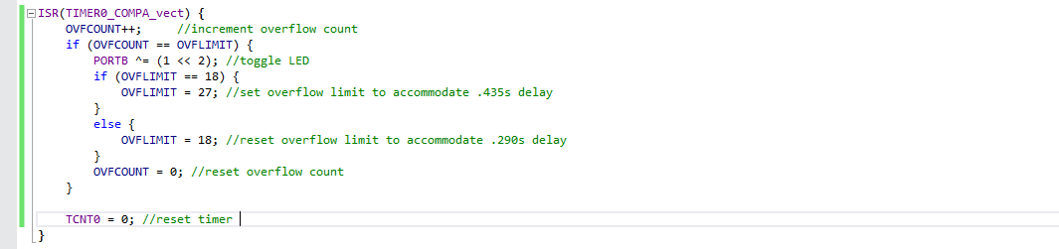

1. **SCHEMATICS**

LEDs

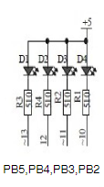

1. **SCREENSHOTS OF EACH TASK OUTPUT (ATMEL STUDIO OUTPUT)**

Task 1

Initialization of timer0 and TCCR0B for the use of 1024 prescaler in Normal mode

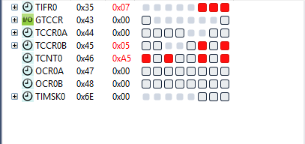

TOV0 in TIFR0 register doesn’t change; is written a 1 to it in order to clear it

When PB2 toggles (LED is on) right when ovfcount reaches the assigned limit

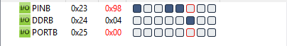

Task 1, Part 2

Timer0 initialization

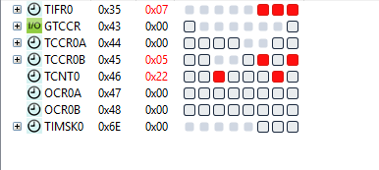

When PC2 (switch) is pressed down

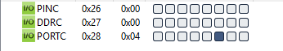

..PB2 (LED) lights up

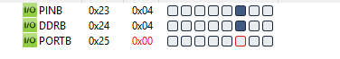

Task 2

Initialization of timer0, TCCR0B, and TIMSK0 registers to enable interrupt and use 1024 prescaler in Normal mode

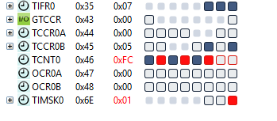

When LED toggles once interrupt occurs and when ovfcount equals a count limit



Task 3

Initialization of timer0, TCCR0B, TIMSK0, and OCR0A registers to enable interrupt, use 1024 prescaler in CTC mode

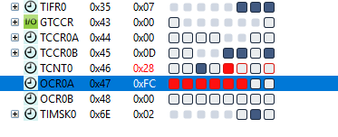

OCR0A initialized to 252

When LED toggles once interrupt occurs and ovfcount equals a count limit



1. **SCREENSHOT OF EACH DEMO (BOARD SETUP)**

Setup:

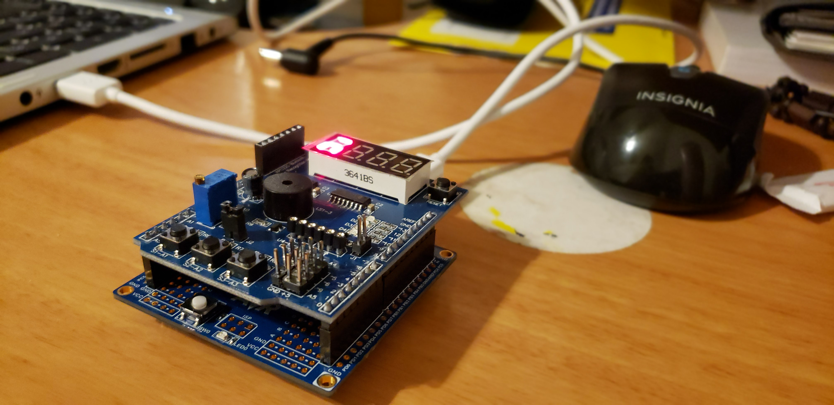

1. **VIDEO LINKS OF EACH DEMO**

<https://www.youtube.com/watch?v=aNAUqZOAuW4>

<https://www.youtube.com/watch?v=3NKe5YZ9_rs>

1. **GITHUB LINK OF THIS DA**

https://github.com/buenj1/submission_da.git

**Student Academic Misconduct Policy**

<http://studentconduct.unlv.edu/misconduct/policy.html>

“This assignment submission is my own, original work”.

JOHN PATRICK BUEN